 | MINISTRY OF EDUCATION AND TRAINING  FPT UNIVERSITY

Software Requirement Specification
Toll Fee Management
Unstoppable
Group Members
  Nguyễn Anh Nhật Linh | 00499
  Nguyễn Duy Vũ | 00521
  Trần Hải Đăng | 00357
  Nguyễn Xuân Hiếu | 00380
  Tô Văn Quân | 00425
Supervisor | Teacher Nguyễn Văn Sang
Ext Supervisor | Huỳnh Anh Dũng,Nguyễn Tất Trung
Capstone Project code | TFM

Hanoi, June 2011

Record of Changes
Date | Change Item | Description | By | Version
22/5/2011 | All | Create the document | LinhNan | 1.0

Table 1-1: References

TABLE OF CONTENTS
Part 1 INTRODUCTION
TABLE OF CONTENTS 3
1 User requirements specification 5
1.1 Introduction 5
1.1.1 Purposes 5
1.1.2 Definition and acronyms 5
1.2 User Requirements 5
2 Software Requirements specification 8
2.1 Introduction 8
2.1.1 Purposes 8
2.1.2 Definition and acronyms 8
2.2 External interface Requirements 8
2.2.1 User Interfaces 8
2.2.2 Hardware Interfaces 8
2.2.3 Software Interfaces 9
2.2.4 Communications Protocol 9
2.3 Functional Specification 10
2.3.1 UC001: [PNRS] Login 10
2.3.2 UC002: [PNRS] Display Camera 12
2.3.3 UC003: [PNRS] Shooting image 13
2.3.4 UC004: [PNRS] Recognize Plate Number by System 15
2.3.5 UC005: [PNRS] Display Transport Info 16
2.3.6 UC006: [PNRS] Print Ticket 17
2.3.7 UC007: [PNRS] Update Price List 18
2.3.8 UC008: [PNRS] Enter Plate Number Info by User 19
2.3.9 UC009: [PNRS] Enter Plate Transport Type Info by User 20
2.3.10 UC010: [PNRS] View Help 21
2.3.11 UC011: [PNRS] Search 22
2.3.12 UC012: [PNRS] Switch Users 23
2.3.13 UC013: [TCMW] Log in 24
2.3.14 UC014: [TCMW] Log Out 27
2.3.15 UC015: [TCMW] Create Account 28
2.3.16 UC016: [TCMW] Delete Account 30
2.3.17 UC017: [TCMW] Add Information 32
2.3.18 UC018: [TCMW] Print Ticket 33
2.3.19 UC019: [TCMW] Ticket Extension 35
2.3.20 UC020: [TCMW] View Revenue 37
2.3.21 UC021: [TCMW] Search 38
2.3.22 UC022: [DSS] Synchronize Data 39
2.4 Non-Functional Requirements 41
2.4.1 Usability 41
2.4.2 Reliability 41
2.4.3 Availability 42
2.4.4 Security 42
2.4.5 Maintainability 42
2.4.6 Design constraints 42
2.4.7 Performance 43
2.5 Entity Relation Model 43
2.5.1 Entity-Relationship Diagram 43

User requirements specification

Introduction

Purposes
This document describes the user requirements of Toll Fee Management, based on the scope that is described in project plan. These requirements will be used to specify the software requirements and architectural design in the Software Specification Document.

Definition and acronyms
Acronyms | Definition | Note
TFM | Toll Fee Management | Name of project
PNRS | Plate Number Recognition System | Name of main application that’s used to recognize plate number.

Table 1-2: Definition and acronyms

User Requirements
- The system must provide a method for the user (in highest level) can create accounts for other users with the information such as username, password, name, address…
- The system should permit/allow users to view the information about their account; be able to manage their account information.
- The system should provide facilities for users to set list of charges for each vehicle that distinguish about cart load (with freight car) or number of seats (with passenger cars).
- The system must provide facilities for users to view the detailed report of revenue of the toll collection station.
- The system provides a method for users to add information to charge of transport such as license plate, date on payment of charge, expired date…
- The system must provide facilities for users to print invoices/ bills for vehicle owners with the information that entered above.
- The detailed report of revenue must have sufficient information such as the number of vehicles through the toll collection station for each type of vehicle by day or by week… and the revenue. Get the information by the periods of time that users enter.
- The system must provide a method to automatic capture and identify the license plate of the vehicle from a camera placed at the toll, then display this image and the information of the vehicle on the screen.
- The displayed screen must have sufficient information of employee is performing task, such as employee ID, date and time of photographing, information of the license plate that has just identified.
- The screen displays exactly information about the vehicle that has just identified, such as: license plate, brand, color, cart load, number of seat, status (monthly or daily ticket), toll… This information must be consistent with the information of the Registry Department.
- The system must provide a method to check whether the transports have paid monthly ticket or not. If the transport paid toll in the month, it can continue the trip. Otherwise the system automatically prints daily ticket for the transport basing on it’s information like kind of car for it to continue the trip
- The system must provide a method for users to search information of a vehicle through the toll collection station by the information that entered by users, such as license plate, date and time, type of vehicle, employee’s work shift…
- The system must provide help information, specific instruction on how to use the identification system for users.
- The system must provide facilities for users to enter information of the vehicle through the toll collection station if it cannot automatically identify.
- The system must provide facilities to print daily ticket for the vehicle that has just identified with right information.
- The system must provide a method for users to view information about all the vehicles through the toll collection station for the periods of time that entered by users.
- The system must user Vietnamese language for all displaying text.
- The interface of the system must be elegant, simple and out-standing.
- The searching tool must be easy to user and quick to show users exactly results
- The PNRS must recognize plate number quickly and exactly, the number plate information of the number plate that’s recognized must be displayed quickly.
- The system must be secure, prevent out instrusion with bad purposes.
- The GUI must be friendly for user to manipulate and see.
- The system must be easy to maintain and less costly.
- The system must provide a method for users tHe thong co kha nang quan ly va xem gio lam cua tung nhan vien trong thoi gian xac dinh
- The system must provide a method to recognize Viet Name standard plate number.
- The system must provide a method to print daily ticket for corresponding transport type.
- Monthly ticket requirements: includes following fields:
- Number plate
- Station name
- Capacity or tonnage
- Shelf
- Daily ticket requirements: includes following fields :
- Number plate
- Date
- Station name
- Price
- Series number
- Daily ticket is just available within the day.

Software Requirements specification

Introduction

Purposes
This document details the software requirements specification, based on user requirements that are defined above. These requirements will be used to specify the software specification document in the Software Specification Document

Definition and acronyms
Acronyms | Definition | Note
TFM | Toll Fee Management | Name of project
PNRS | Plate Number Recognition System | Name of main application that’s used to recognize plate number.
TCMW | Toll Collection Managerment Website | The website that’s used to manage toll collection.
DSS | Date Sychronization System | Name of the application to synchronize data from Viet Nam Register data base.

Table 1-3: Definition and acronyms

External interface Requirements

User Interfaces
- Interface of TCMW should have the background simple, less color, less attention but that also shows clear boundaries between each section: photos with text, photos with photos, and photos with the background…So color choices should be pleasing to the eye and should stimulate the user's interest.
- Interface of PNRS: on the left side of the monitor there is the screen to display data from camera; the next is a part to display the picture of the latest plate number. The toolbar in enabled and it sets up right down the top menu. On the right side of the screen is the context information such as employee ID, date time, text of plate number ... On the bottom side of the screen is information of the plate number that’s recognized.

Hardware Interfaces
- TCMW needs to run are the peripheral devices:
- Mouse and keyboard for users to manipulate the web
- Printer to export hard copy of reports.
- PNRS needs to run are the perriphenal devices:
- Mouse and keyboard for users to manipulate with app interface.
- Printer to print tickets for transports.
The system can support many image formats such as: jpg, bmp, jpeg.

Software Interfaces
- TCMW runs on web application, it requires the use of programming languages supported on the browser, runs on .NET Framework 4.0 platform of Windows 7 and IIS.
- PNRS and DSS run on .Net NET Framework 4.0 platform of Windows 7.
- Database of the system run on SQL Server R2 of Microsoft.

Communications Protocol
- DSS uses the HTTP protocol used for retrieving rerouce by to calling provide servire and other information.
- System implemented on the browser, using standard protocols to communicate between users and server.
- Besides the design of DSS, all components of the system can access data at any time.

Functional Specification

UC001: [PNRS] Login

Use Case Diagram
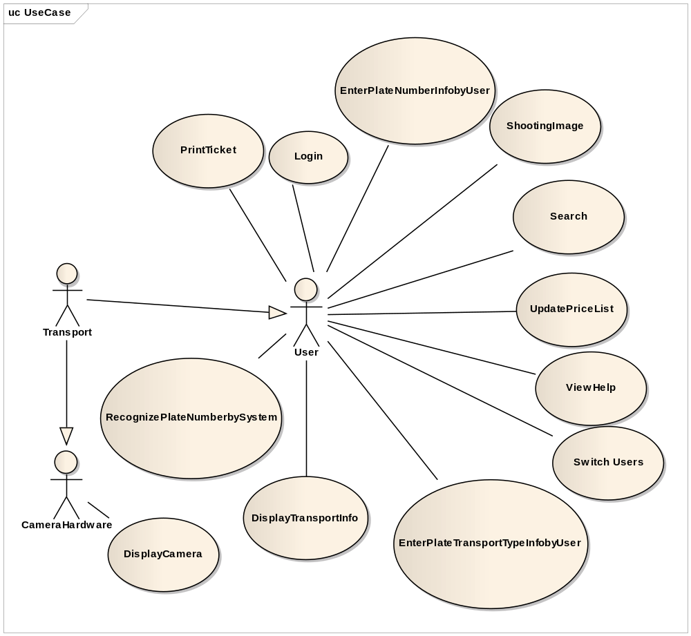
Figure 1-1: [PNRS] User case diagram

Use Case Specification

USE CASE - SPECIFICATION
Use-case No.  Use-case Name  Author | UC001 | Version | 1.0
Use-case No.  Use-case Name  Author | [PNRS] Log in
Use-case No.  Use-case Name  Author | Vu ND
Date | 1/6/2011 | Priority | High

Actor :
- User.

Summary :
- User must be login to be able to start the main application, using the account that admin create and allocate access right.

Triggers :
- When user presses button “Đăng nhập”.
Preconditions :
- User run executable file to start the program.

Post Conditions :
- Show login form.

Main Success Scenario :
- Login form loaded with 2 textboxes: username textbox and password textbox.
- User type username to username textbox and password to password textbox.
- User presses “Đăng nhập” button.
- Main form is loaded if user types his/her account right.

Alternative Scenario :

None.

Exceptions :

At step 3 :
- If user types nothing in username textbox but user types in password textbox before press Enter/ “Đăng nhập”, the message box: “Hãy nhập tài khoản” is showed.
- If user types nothing in password textbox but user types in username textbox before press Enter/ “Đăng nhập”, the message box: “Hãy nhập mật mã” is showed.
- If user types nothing in both textboxes, the message box: “Hãy nhập tài khoản” is showed.
- If user types wrong username or password , error message “Tài khoản hoặc mật mã không chính xác” is showed

Relationships:

The case related to Main form.

Business Rules :
- Maximum characters of login user are 16 and of password are 32.
- Username and password must not contain special character.

UC002: [PNRS] Display Camera

Use Case Diagram
See [2.3.1.1]

Use Case Specification

Use Case - Specification
Use-case No.  Use-case Name  Author | UC002 | Version | 1.0
Use-case No.  Use-case Name  Author | [PNRS] Display Camera
Use-case No.  Use-case Name  Author | LinhNan
Date | 1/6/2011 | Priority | High

Actor :
- Camera harware

Summary :
- Image from camera will appear on the left side of main screen for user to see.

Triggers :
- When user clicks on “Đăng nhập” on form login.

Preconditions :
- User logged into the system successfully.

Post Conditions :
- Image from camera is displayed on the screen.

Main Success Scenario :
- Searching camera installed device.
- Reuquest load image from the camera
- Display image on screen.

Alternative Scenario :
- None.

Relationships:
- UC001.

Business Rules :
- None.

UC003: [PNRS] Shooting image

Use Case Diagram See [2.3.1.1]

Use Case Specification

Use Case - Specification
Use-case No.  Use-case Name  Author | UC003 | Version | 1.0
Use-case No.  Use-case Name  Author | [PNRS] Shooting image
Use-case No.  Use-case Name  Author | LinhNan
Date | 1/6/2011 | Priority | High

Actor :
- User.

Summary :
- Camera will shoot the car when it stops in front of barrier.

Triggers :
- When users click button “Chụp ảnh”.

Preconditions :
- When transports come to toll station’s defined position.

Post Conditions :
- Image from camera is displayed on the screen.

Main Success Scenario :
- Searching camera installed device.
- Reuquest load image from the camera
- Display image on screen.

Alternative Scenario :
- None.

Relationships:
- UC001.

Business Rules :
- None.

UC004: [PNRS] Recognize Plate Number by System

Use Case Diagram See [2.3.1.1]

Use Case Specification

Use Case - Specification
Use-case No.  Use-case Name  Author | UC004 | Version | 1.0
Use-case No.  Use-case Name  Author | [PNRS] Recognize Plate Number by System
Use-case No.  Use-case Name  Author | QuanTV
Date | 1/6/2011 | Priority | High

Actor :
- User.

Summary :
- Plate number information will be recognized with the type is text and is displayed on screen.

Triggers :
- When users click button “Chụp ảnh”.

Preconditions :
- When transports come to toll station’s defined position.

Post Conditions :
- N/A.

Main Success Scenario :
- Convert the image to gray color.
- Trim the plate number text area of the image
- Convert the plate number text area to text.
- Display plate number information on screen.

Alternative Scenario :
- None.

Relationships:
- UC003.

Business Rules :
- Format of the plate number is according national standards.

UC005: [PNRS] Display Transport Info

Use Case Diagram See [2.3.1.1]

Use Case Specification

Use Case - Specification
Use-case No.  Use-case Name  Author | UC005 | Version | 1.0
Use-case No.  Use-case Name  Author | [PNRS] Display Transport Info
Use-case No.  Use-case Name  Author | QuanTV
Date | 1/6/2011 | Priority | High

Actor :
- User.

Summary :
- Check whether the transports have paid monthly ticket or not basing on the text of the plate number that has been recognized.

Triggers :
- When users click button “Chụp ảnh”.
- Users enter the plate number info and click button “Check” (in case: the system cannot recognize the plate nunber).

Preconditions :
- The plate number is recognized by user or the system.

Post Conditions :
- N/A.

Main Success Scenario :
- Query database with the input data is the text that is recognized.
- Check existence of the plate number in the database.
- Get transport’s type field.
- Check whether the transports have paid monthly ticket or not
- Display monthly ticket status and toll that depends on the type of the transport on screen.
Alternative Scenario :
- None.

Relationships:
- UC004.

Business Rules :
- Format of the plate number is according national standards.

UC006: [PNRS] Print Ticket

Use Case Diagram See [2.3.1.1]

Use Case Specification

Use Case - Specification
Use-case No.  Use-case Name  Author | UC006 | Version | 1.0
Use-case No.  Use-case Name  Author | [PNRS] Print Ticket
Use-case No.  Use-case Name  Author | QuanTV
Date | 1/6/2011 | Priority | High

Actor :
- User.

Summary :
- Print ticket for the transport in case it has not paid monthly fee.

Triggers :
- When users click button “In vé”.
Preconditions :
- The plate number is recognized by user or the system.

Post Conditions :
- N/A.

Main Success Scenario :
- Query database with the input data is the text that is recognized.
- Check existence of the plate number in the database.
- Get transport’s type field.
- Check whether the transports have paid monthly ticket or not
- Display monthly ticket status and toll that depends on the type of the transport on screen.
Alternative Scenario :
- None.

Relationships:
- UC004.

Business Rules :
- Format of the plate number is according national standards.

UC007: [PNRS] Update Price List

Use Case Diagram See [2.3.1.1]

Use Case Specification

Use Case - Specification
Use-case No.  Use-case Name  Author | UC007 | Version | 1.0
Use-case No.  Use-case Name  Author | [PNRS] Update Price List
Use-case No.  Use-case Name  Author | QuanTV
Date | 1/6/2011 | Priority | High

Actor:
- User.

Summary :
- Update price list of toll when there’s some change of toll from department concerned.

Triggers :
- When users click button “Cập nhật bảng giá”.
- Display latest price that’s updated from department concerned.
Preconditions :
- When there’s some change of toll from department concerned and users are informed to update the change.

Post Conditions :
- N/A.

Main Success Scenario :
- Users click button “Cập nhật bảng giá”.

Alternative Scenario :
- None.

Relationships:
- None

Business Rules :
- None.

UC008: [PNRS] Enter Plate Number Info by User

Use Case Diagram See [2.3.1.1]

Use Case Specification

Use Case - Specification
Use-case No.  Use-case Name  Author | UC008 | Version | 1.0
Use-case No.  Use-case Name  Author | [PNRS] Enter Plate Number Info by User
Use-case No.  Use-case Name  Author | QuanTV
Date | 1/6/2011 | Priority | High

Actor :
- User.

Summary :
- Enter plate number info by users’ eyes when the system cannot recognize the plate number because of some objective reasons.

Triggers :
- When users click button “Nhận”.
Preconditions :
- The plate number canot be recognized by the system.

Post Conditions :
- Controls for user typing are active.

Main Success Scenario :
- Type the plate number information into “Biển số” textbox.
- Click button “Nhận”.
- Display plate number information on screen

Alternative Scenario :
- None.

Relationships:
- UC004.

Business Rules :
- Format of the plate number is according national standards.

UC009: [PNRS] Enter Plate Transport Type Info by User

Use Case Diagram See [2.3.1.1]

Use Case Specification

Use Case - Specification
Use-case No.  Use-case Name  Author | UC009 | Version | 1.0
Use-case No.  Use-case Name  Author | [PNRS] Enter Plate Transport Type Info by User
Use-case No.  Use-case Name  Author | QuanTV
Date | 1/6/2011 | Priority | High

Actor :
- User.

Summary :
- Users enter transport type information when the plate number does not exist in database.

Triggers :
- When users click button “Nhận”.
Preconditions :
- The plate number information does not exist in database.

Post Conditions :
- Textbox “Loại xe” for user typing is active.

Main Success Scenario :
- Type the transport type into “Loại xe” textbox.
- Click button “Nhận”.
- Display plate number information on screen

Alternative Scenario :
- None.

Relationships:
- UC004.
- UC009

Business Rules :
- None.

UC010: [PNRS] View Help

Use Case Diagram See [2.3.1.1]

Use Case Specification

Use Case - Specification
Use-case No.  Use-case Name  Author | UC009 | Version | 1.0
Use-case No.  Use-case Name  Author | [PNRS] View Help
Use-case No.  Use-case Name  Author | QuanTV
Date | 1/6/2011 | Priority | High

Actor:
- User.

Summary :
- View helps information from the program if something’s not clear.

Triggers :
- When users click “Giúp đỡ” from menu bar.
Preconditions :
- When user want to view helps information from the program.

Post Conditions :
- N/A.

Main Success Scenario :
- Users click “Giúp đỡ” from menu bar.
- Display help dialog.

Alternative Scenario :
- None.

Relationships:
- None

Business Rules :
- None.

UC011: [PNRS] Search

Use Case Diagram See [2.3.1.1]

Use Case Specification

Use Case - Specification
Use-case No.  Use-case Name  Author | UC011 | Version | 1.0
Use-case No.  Use-case Name  Author | [PNRS] Search
Use-case No.  Use-case Name  Author | QuanTV
Date | 1/6/2011 | Priority | High

Actor:
- User.

Summary :
- Search turns information overing the station by logged user.

Triggers :
- When users click button “Xem”.
Preconditions :
- When users want to view Search turns information overing the station.

Post Conditions :
- Search area is active.

Main Success Scenario :
- Users type parameters into textbox place number, type of transport, date.
- Click button “Xem’.
- Display all information that is searched on screen.

Alternative Scenario :
- None.

Relationships:
- None

Business Rules :
- None

UC012: [PNRS] Switch Users

Use Case Diagram See [2.3.1.1]

Use Case Specification

Use Case - Specification
Use-case No.  Use-case Name  Author | UC010 | Version | 1.0
Use-case No.  Use-case Name  Author | [PNRS] View Help
Use-case No.  Use-case Name  Author | QuanTV
Date | 1/6/2011 | Priority | High

Actor:
- User.

Summary :
- Switch to another user for logger user.

Triggers :
- When users click “Chuyển người dùng” in menubar.
Preconditions :
- Want to change staff to another.

Post Conditions :
- Login form appears in dialog type.

Main Success Scenario :
- Users click “Chuyển người dùng” in menubar.
- Type user name and password.
- Click “Đăng nhập” button
- Display new logged user info.

Alternative Scenario :
- None.

Relationships:
- UC001

Business Rules :
- None

UC013: [TCMW] Log in

Use Case Diagram
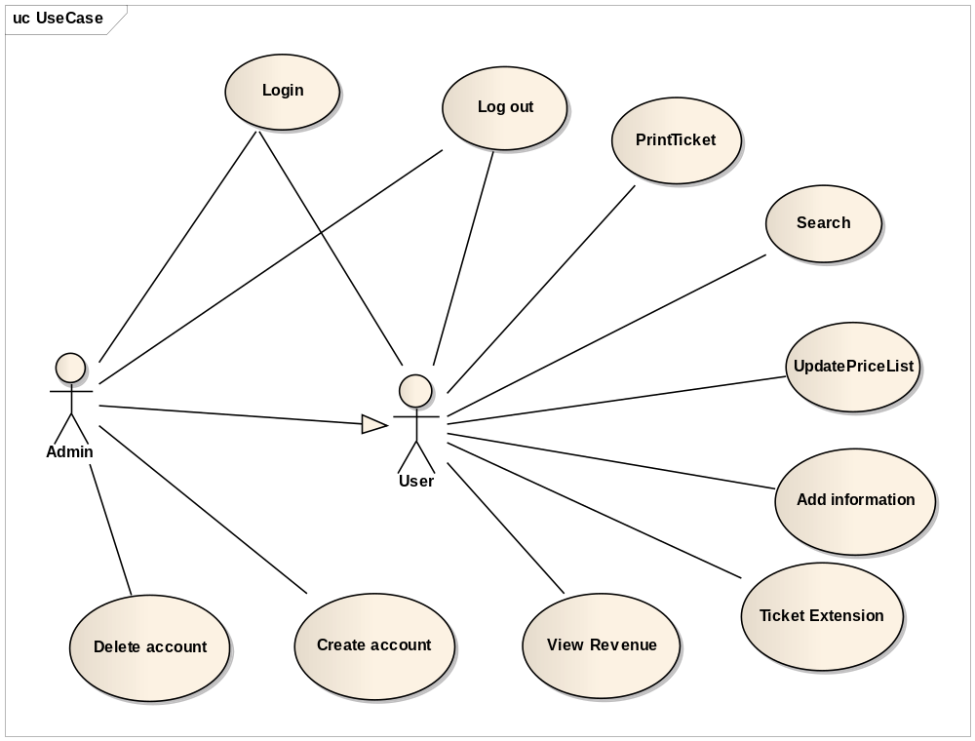
Figure 1-2: [TCMW] User case diagram

Use Case Specification

USE CASE - SPECIFICATION
Use-case No.  Use-case Name  Author | UC013 | Version | 1.0
Use-case No.  Use-case Name  Author | [TCMW] Log in
Use-case No.  Use-case Name  Author | Vu ND
Date | 1/6/2011 | Priority | High

Actor :
- User.

Summary :
- After login page is loaded, user can type user name and password to access to system.

Goal :
- Users can login to system when they type user name and password exactly.

Triggers :
- When user presses button “Đăng nhập”.
Preconditions :
- Login page loaded successfully.
- User types username and password to the username textbox and password textbox.

Post Conditions :
- Show main page.

Main Success Scenario :
- Login page loaded with 2 textboxes: username textbox and password textbox.
- User type username to username textbox and password to password textbox.
- User presses “Đăng nhập” button.
- Main page is loaded if user types his/her account right.

Alternative Scenario :
- None.

Exceptions :
- At step 3 :
- If user types nothing in username textbox but user types in password textbox before press Enter/ “Đăng nhập”, the message box: “Hãy nhập tài khoản” is showed.
- If user types nothing in password textbox but user types in username textbox before press Enter/ “Đăng nhập”, the message box: “Hãy nhập mật mã” is showed.
- If user types nothing in both textboxes, the message box: “Hãy nhập tài khoản” is showed.
- If user types wrong username or password , error message “Tài khoản hoặc mật mã không chính xác” is showed
- At step 4 :
- Cannot redirect user to the Main Page.
- The error page is showed.

Relationships:

The case related to Main page.

Business Rules :
- Login function must always available for anyone visits the website.
- In order to log in to the system, user name and password are required.

UC014: [TCMW] Log Out

Use Case Diagram See [2.3.13.1]

Use Case Specification

USE CASE - Log out SPECIFICATION
Use-case No.  Use-case Name  Author | UC014 | Version | 1.0
Use-case No.  Use-case Name  Author | [TCMW] Log out
Use-case No.  Use-case Name  Author | Vu ND
Date | 1/6/2011 | Priority | High

Actor :
- User.

Summary :
- After done using the website and plan to leave, the user can log out of the system.

Goal :
- Allow user to log out website.

Triggers :
- When user clicks on “Thoát” at the top right corner of website.

Preconditions :
- Logged into the system.

Post Conditions :
- Display user as guest.

Main Success Scenario :
- Redirect to home page, Login form is showed.

Alternative Scenario :
- None.

Exceptions :
- None.

Relationships:
- Login function.

Business Rules :
- None.

UC015: [TCMW] Create Account

Use Case Diagram See [2.3.13.1]

Use Case Specification

USE CASE - SPECIFICATION
Use-case No.  Use-case Name  Author | UC015 | Version | 1.0
Use-case No.  Use-case Name  Author | [TCMW] Create account
Use-case No.  Use-case Name  Author | Vu ND
Date | 1/6/2011 | Priority | High

Actor :
- Admin

Summary :
- Admin creates an account for new user.

Goal :
- New user has his/her account

Triggers :
- When admin clicks on “Tạo” button.

Preconditions :
- Logged into the system.

Post Conditions :
- Display user as guest.

Main Success Scenario :
- Redirect to home page, “Đăng nhập” and “Đăng kí” button appear instead of user name, user point and “Thoát” button on log in area at top right corner of the website

Alternative Scenario :
- None.

Exceptions :
- None.

Relationships:
- Login function.

Business Rules :
- None.

UC016: [TCMW] Delete Account

Use Case Diagram See [2.3.13.1]

Use Case Specification

USE CASE - SPECIFICATION
Use-case No.  Use-case Name  Author | UC016 | Version | 1.0
Use-case No.  Use-case Name  Author | [TCMW] Delete account
Use-case No.  Use-case Name  Author | Vu ND
Date | 1/6/2011 | Priority | High

Actor :
- Admin

Summary :
- Admin deletes account of users who do not work in station anymore.

Goal :
- Delete all accounts which do not suitable

Triggers :
- When admin clicks on “Xóa” button.
Preconditions :
- Logged into the system.

Post Conditions :
- Display user as guest.

Main Success Scenario :
- Redirect to home page, “Đăng nhập” and “Đăng kí” button appear instead of user name, user point and “Thoát” button on log in area at top right corner of the website

Alternative Scenario :
- None.

Exceptions :
- None.

Relationships:
- UC013.

Business Rules :
- None.

UC017: [TCMW] Add Information

Use Case Diagram See [2.3.13.1]

Use Case Specification

USE CASE - SPECIFICATION
Use-case No.  Use-case Name  Author | UC017 | Version | 1.0
Use-case No.  Use-case Name  Author | [TCMW] Add Information
Use-case No.  Use-case Name  Author | Vu ND
Date | 1/6/2011 | Priority | High

Actor :
- User.

Summary :
- The car information like Plate Number, Ticket’s Start Date ,Ticket’s End Date can be added

Goal :
- User can add information of cars

Triggers :
- When user presses button “Thêm ”
Preconditions :
- User logged in to system

Post Conditions :
- The car information is added

Main Success Scenario :
- The car information can be viewed

Alternative Scenario :
- None.

Exceptions :
- Database does not have car information

Relationships:
- None.

Business Rules :
- User can not delete or edit information which is added

UC018: [TCMW] Print Ticket

Use Case Diagram See [2.3.13.1]

Use Case Specification

USE CASE - SPECIFICATION
Use-case No.  Use-case Name  Author | UC018 | Version | 1.0
Use-case No.  Use-case Name  Author | [TCMW] Print Ticket
Use-case No.  Use-case Name  Author | Vu ND
Date | 1/6/2011 | Priority | High

Actor :
- User.

Summary :
- Staff prints a ticket for a driver who bought it.

Goal :
- The ticket can be printed

Triggers :
- When user presses button “In ”
Preconditions :
- User logged in to system
- Drivers pay money for tickets

Post Conditions :
- The ticket is printed

Main Success Scenario :
- The ticket is printed exactly and successfully

Alternative Scenario :
- None.

Exceptions :
- None

Relationships:
- UC017

Business Rules :
- None

UC019: [TCMW] Ticket Extension

Use Case Diagram See [2.3.13.1]

Use Case Specification

USE CASE - SPECIFICATION
Use-case No.  Use-case Name  Author | UC019 | Version | 1.0
Use-case No.  Use-case Name  Author | [TCMW] Ticket Extension
Use-case No.  Use-case Name  Author | Vu ND
Date | 1/6/2011 | Priority | High

Actor :
- User.

Summary :
- Staffs add more time for a monthly or yearly ticket.

Goal :
- The ticket can be extended

Triggers :
- When user presses button “Gia hạn ”
Preconditions :
- User logged in to system
- Ticket information is showed

Post Conditions :
- The ticket is extended

Main Success Scenario :
- The ticket information form is showed
- The ticket is extended exactly and successfully

Alternative Scenario :
- None.

Exceptions :
- None

Relationships:
- None

Business Rules :
- Only extend for monthly and yearly ticket

UC020: [TCMW] View Revenue

Use Case Diagram See [2.3.13.1]

Use Case Specification

USE CASE - SPECIFICATION
Use-case No.  Use-case Name  Author | UC00 | Version | 1.0
Use-case No.  Use-case Name  Author | [TCMW] View Revenue
Use-case No.  Use-case Name  Author | Vu ND
Date | 1/6/2011 | Priority | High

Actor :
- User.

Summary :
- View all information of station’s revenue.

Goal :
- User can view revenue report. The report must have : the number of vehicles for each type , revenue follow number of vehicles for each type , total revenue….

Triggers :
- When user presses button “Xem thông tin ”
Preconditions :
- User logged in to system
- Revenue information form is showed

Post Conditions :
- The revenue report can be viewed

Main Success Scenario :
- The revenue report is showed

Alternative Scenario :
- None.

Exceptions :
- None

Relationships:
- None

Business Rules :
- None

UC021: [TCMW] Search

Use Case Diagram See [2.3.13.1]

Use Case Specification

Use Case - Specification
Use-case No.  Use-case Name  Author | UC021 | Version | 1.0
Use-case No.  Use-case Name  Author | [TCMW] Search
Use-case No.  Use-case Name  Author | QuanTV
Date | 1/6/2011 | Priority | High

Actor:
- User.

Summary :
- Search information of a vehicle through the toll collection station by the information that entered by users, such as license plate, date and time, type of vehicle, employee’s work shift.

Triggers :
- Users enter search criteria and click search button.
Preconditions :
- Logged in the website.

Post Conditions :
- The page navigates to search result screen with the result displayed.

Main Success Scenario :
- Users type parameters into textbox place number, type of transport, date.
- Click button “Tìm kiếm.
- Display all searched result.

Alternative Scenario :
- None.

Relationships:
- None

Business Rules :
- None

UC022: [DSS] Synchronize Data

Use Case Diagram
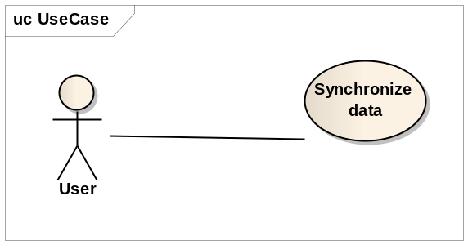
Figure 1-4: [TCMW] User case diagram

Use Case Specification

Use Case - Specification
Use-case No.  Use-case Name  Author | UC022 | Version | 1.0
Use-case No.  Use-case Name  Author | [DSS] Synchronize Data
Use-case No.  Use-case Name  Author | QuanTV
Date | 1/6/2011 | Priority | High

Actor:
- User.

Summary :
- Synchronize data of local database with deparment concerned’s database.

Triggers :
- Users start executable file.
Preconditions :
- When there’s some new plate number that’s registered.

Post Conditions :
- None.

Main Success Scenario :
- Request to get data from department concerned database with interval time that is configured.

Alternative Scenario :
- None.

Relationships:
- None.

Business Rules :
- None.

Non-Functional Requirements

Usability

GUI
- All the text, image text and help documents should be in Vietnamese.
- The interface should be elegant, simple and out-standing.
- The images must be simple and easy to see

Usability for end-users
- Searching tool should be easy to use.
- The website must provide a help page to support novice users.
- The system should remember information (but not confidential) that users have to provide regularly. For example: name, address…

Usability for admin and staff
- Website admin and station’s staff should need only one day of training to be familiar with the system and the application.
- Admin and staff can know about system more exactly with help pages and separate documents.

Installation
- The system must be easy to deploy.
- The documentation for installation must be included. It describes detailed steps for installing or deploying the system. Users can follow the steps without direct help from the developing team.

Reliability
- Initial data must be collected carefully and correctly
- Not conflict with other software
- Bugs or Defect Rate

Type of Defect | Description | Number allowed
Fatal | Showstopper - tester cannot proceed with any tests  e.g. system crash | 0
Serious | Tester cannot proceed with any tests on one area of functionality | 30
Medium | The bug does not stop testing - but limits it  e.g. data validation wrong | 72
Cosmetic | The defect is not business logic error, it can be typo text, field length… e.g. screen spelling or error message wrong. | 45

Table 1-4: Reliability

Availability
- Systems have to run 24 hours 7 days
- It must be available all the working time, and can be down in the off-time for maintaining.
- Percentage of time available is about 95% because we can not control some problems such as network disconnecting, power failure…..

Security
- Password must be encrypted
- Only one person has admin permission

Maintainability

Coding standards and naming conventions
- Output of the project must include coding standards and naming conventions documentations. Implementation code must be easy to maintain.
- All code must be clearly commented, including class, method documentations.
- If some components are reused, the documentations of those components must also be included.

Logging
- All the errors should be logged, supporting for bug fixing and maintenance.
- All strange or sensitive situations should also be logged.

Email
- The system must provide an email address to receive users’ feedback or send emails.

Design constraints

Date/Time Format
- Default date format is dd-mm-yyyy For example: 10-05-2008
- Default time format is HH24:MM For example: 17:23

Number Format
- Decimal places of % is 1 For example: 25.7%
- Decimal for length and height is 1 For example: 2.2
- Currency format is ##,###,##0.00 (# is digit)

Multi Language
The system will be implemented to support for Vietnamese only . The system should support for internationalization & multiple locations in future.

Page size
The system should be designed and developed to generate HTML page size less than or equal to 50KB, except for some special cases.

Others
The system should be designed work irrespective of any settings on the client workstations in which IE7.0 or above has been installed and run properly.

Performance

Load time
- Every page should be completely displayed within: average 1.5 second and maximum 5 seconds.
- Application must be loaded from 2 seconds to 6 seconds
- Searching should return and display the result within 2 seconds.
- Data must be cached

System throughout
- The system must be capable of scaling up-to 200 users with the addition of faster or greater capacity hardware without software changes. It can support for 120 concurrent logged users into the system.
- The system must be able to process and still meet the response-time targets up-to a maximum of 10000 user-transactions per day for insert, update, & query transactions.
- If the system is busy, it has to inform users about that.

Compatibility
- The system should provide elegant responses for nowadays common screen resolutions: 1024*768, 1280*800.
- The output must be compatible with all common browsers: Mozilla Firefox, Internet Explorer, Google Chrome and Opera.

Entity Relation Model

Entity-Relationship Diagram

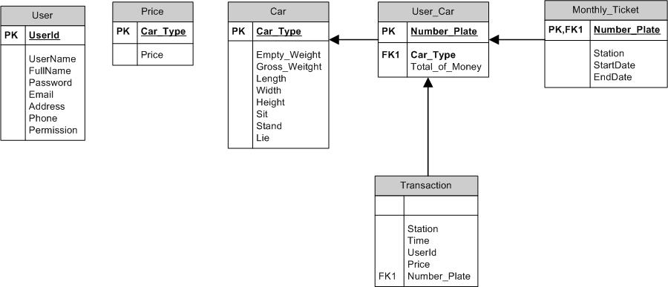
Figure 1-3: Entity-Relationship Diagram

